# WEATHER MONITORING SYSTEM

AL AMIN SOHAG,

1510708642

Department of CSE, NSU

**ABSTRACT –** A weather station is a facility equipped with high-tech instruments for predicting future weather phenomenon. This is also used to study the climate of that area. The measurements taken from the station include – temperature, pressure, humidity, wind speed, precipitation. The accuracy predicted by these weather stations is not too high to predict the actual weather condition for a particular area. The error difference may be around 10% which makes a huge difference. Plus, in every city there are 2-3 weather stations only for predicting weather of an area as wide as 426km2. The weather stations give the prediction for the whole city and not just a particular area. Each area might have different climate since the weather depends on location. This paper formulates the mechanism to improve the accuracy.

**KEYWORDS –** Sensors, Accuracy, Analysis, Arduino, Graph, Prediction

## INTRODUCTION

Weather prediction is done by extensive analysis of data that is collected over a period of time. The climatic data of a particular location has various attributes like – temperature, pressure, wind, sunlight, rain. All these factors and their intermediaries contribute to the prediction of the climate under consideration. The analysis is done by the based on current data and historical data. Using various algorithms that can model the data.

A small change in weather phenomenon can have a devastating impact on the climate of that area. These nay be due to tides, sun rays, and atmospheric pressure. All of these are inter-related. It also becomes difficult to predict future weather more than a few days ahead, since climate is continuously changing. Tomorrow’s climate may be further impacted by other meteorological phenomenon.

Human interaction is needed since we need to determine the correct model that needs to be built. Even if we use Artificial Intelligence or Machine Learning Algorithms for the analysis, we need to have the correct model. If model is wrong, then analysis is like a needle in a haystack.

## LITERATURE REVIEW

Previous systems that existed are only on collection of climate data or transmission of these data using ZigBee or GSM or Wi-Fi or some remote mechanism. All these system, though they measure the same parameters but they lack one common thing and that is accuracy. People need accurate weather condition of the area they live in. They need to know the weather so that they can thrive and adapt according to it.

Other systems collect data and predict tomorrow’s weather data just like that. No patter, no observation are made. This makes the prediction error prone. This method is applicable only to places where there are not so many weather fluctuations occurring in the area i.e. it is stable throughout. Since normal prediction would fail when the outliers are more.

Nowadays, weather station use heavy instruments to determine the weather of the city. These instruments cost high and their accuracy is not too much to rely on.

## PROPOSED SYSTEM

To improve the accuracy of the above mentioned technique, we would be making the weather stations localized. Now we cannot have the whole unit at each and every area. This would incur a lot of expenses and area. To reduce that we would build a mini weather station on top of every building there is in the city. Suppose, if there are 1 million building, there will be 1 million mini weather stations incorporated on the top just like a Tata Sky antenna is installed. This would help in collecting data from each area of the city, to be specific each building.

Now, consider Location A which is surrounded by location B, C, D and E on 4 sides. Now we can have 5 possibilities of mapping Location A weather i.e. location A weather itself,

Location A and B, Location A and C, Location A and D, Location A and E.

All these mapping done together will help in predicting the weather of the Location A to a good accuracy point. Since, weather is dependent and contagious (sort of), learning of the locations dependency will help in resolving/predicting the weather accurately.

An algorithm will be used to learn each locations weather and its neighbouring locations dependencies which will help in currently identifying the climate. Thus people of that area can make plans accordingly depending on the weather predicted by the mini stations. The equipment will be covered in a proper ventilated box, so that it is invulnerable to nature’s wrath but in return help in collecting and forecasting weather.

**OUTCOME**

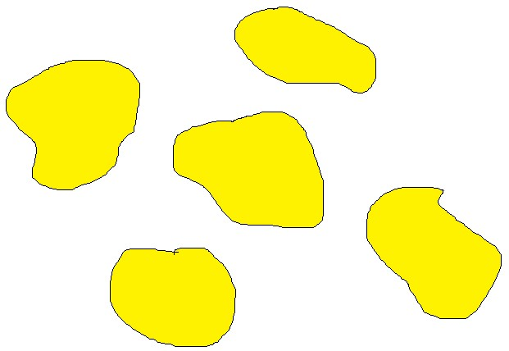

A



B



C



D



E



Weather been

mapped from its

neighbours

The expected outcome is to improve the accuracy of the weather being predicted. The error before was around 10%. This proposed mechanism should reduce the error to 2% which is a significant improvement over the previous existing one. The range of the device being installed is limited to 1 building. So the data collected would be over every m2. This data would be consistent and similar to the data collected by just 2-3 weather stations. The only difference would be the accuracy of the data to every decimal and forecasting of weather to the actual one.

The result will be displayed on the mobile app Screen of each building so that the occupants can check their local area weather. Also, these data can be collected and mapped to be displayed on their states weather report website. They can accurately check the weather of the area they want to visit, travel, etc. Therefore, the people can plan their moves accordingly i.e. at what time should they leave or visit for safe travel.

The data being collected will be transmitted to the data center via radio waves since they require no complications required

for transmission. The data can be sent via different frequency so that there is very less interference of data. It is a cheaper method of sending data.

The data center collects data from these 1 million houses and maps the data simultaneously to predict weather changes every hour. The data is also collected to report any anomaly that can occur in the near future (just like stock market they vary depending on the structures and clues as explained by the Elliots Wave Theory principle). Also, as said above, the data is mapped for accurate prediction.

## COMPONENTS

**ARDUINO** is an open-source electronics platform based on easy-to-use hardware and software. It is intended for anyone making interactive projects. Arduino senses the environment by receiving inputs from many sensors, and affects its surroundings by controlling lights, motors and other actuators.

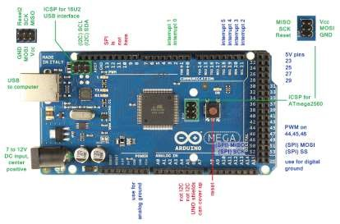

**DHT11** is a temperature and humidity sensor which has 4 pins. One is voltage, other is ground and third is data pin which is used for transmission of data from sensor to Arduino and last pin is not connected called NC pin.

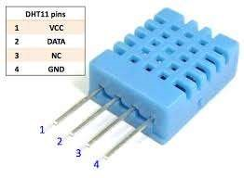

## ARCHITECURE DESIGN



Data

center

Collection



Knowledge Base



Required data like temperature,

pressure, humidity will be stored for

future use



Gateway



Communication

medium



Transmitting Daily weather

conditions per hour



Analysis of each

locations

weather



Display weather

## EXPERIMENTAL RESULTS

Suppose a person wants to go to a particular location (say B) from A. Now that person wants to plan his travel accordingly such that he does not have to face the extreme weather conditions of the locations. So he can see the weather of the 2 locations at different time of the day and depending on that he can plan his moves.

For example, Location A will have temperature 35oC at noon and 25oC around 5pm. Location B will have rain occurring in the morning and dry weather by 5pm and the journey time is 1 pm. So, he decides to move at 4 pm where he does not have to face any problems.

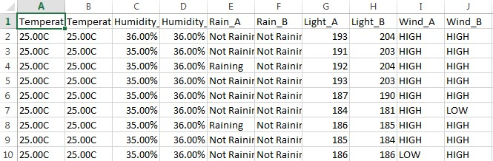

## CONCLUSION

This work states that the accuracy can be improved even further with well-defined algorithms that can map these data. We can utilize Deep-learning to successfully do that. The data being collected is stored for later use by any other organization which can try and improve the accuracy to upto 100%.

**REFERENCES:**

1. Satoh. F, Itakura. M, “Cloud-based Infrastructure for Managing and Analyzing Environmental Resources”, SRII Global Conference, pp.325- 334, 201.
2. Kurschl. W, Beer W, “Combining cloud computing and wireless sensor networks”, International Conference on Information Integration and Web-based Applications and Services, pp.512-518, 2009.
3. Zhengtong. Y, Wenfeng. Z, “The research of environmental pollution examination system based on the Cloud Computing”, International Conference on Communication Software and Networks, pp.514-516, 2011.
4. Montgomery. K, Chiang. K, “A New Paradigm for Integrated Environmental Monitoring”, ACM International Conference Proceeding Series, 2010.
5. Wei. Q, Jin. N, Lou X, Ma. R, Xu. J, “Software design for water environment remote monitoring system based on mobile devices”,

Applied Mechanics and Materials, pp. 2027-2032, 2011 [6] Kang. J. and Park S. “Integrated comfort sensing system on indoor climate” Sensors and Actuators. 2000. 302- 307.

1. Moghavvemi M. and Tan. S. “A reliable and economically feasible remote sensing system for temperature and relative humidity measurement”. Sensors and Actuators. 2005. 181-185.

[View publication stats](https://www.researchgate.net/publication/318463522)